Digital USB Microscope

USB-MICROSCP

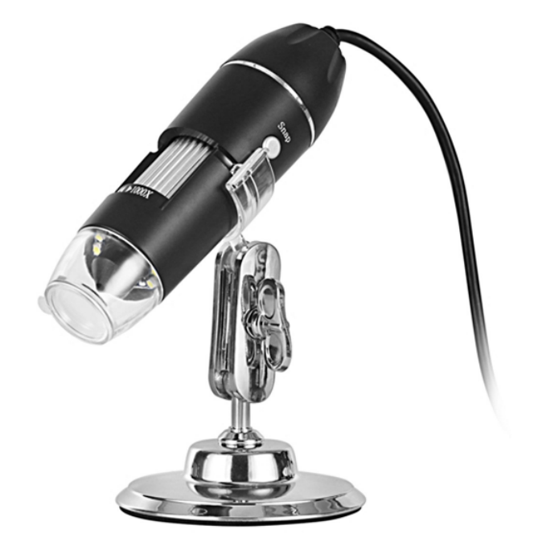

Quick Details
Theory:Digital Microscope
Product name:USB Digital Microscope
type:1000x usb digital microscope
Resolution:480p
Frame Rate:30fps
LED:8 White LED
camera:0.3 mega pixel
Video Format:AVI
Magnification Range:0-1000X
size:11*3.3cm
accept Customized:yes

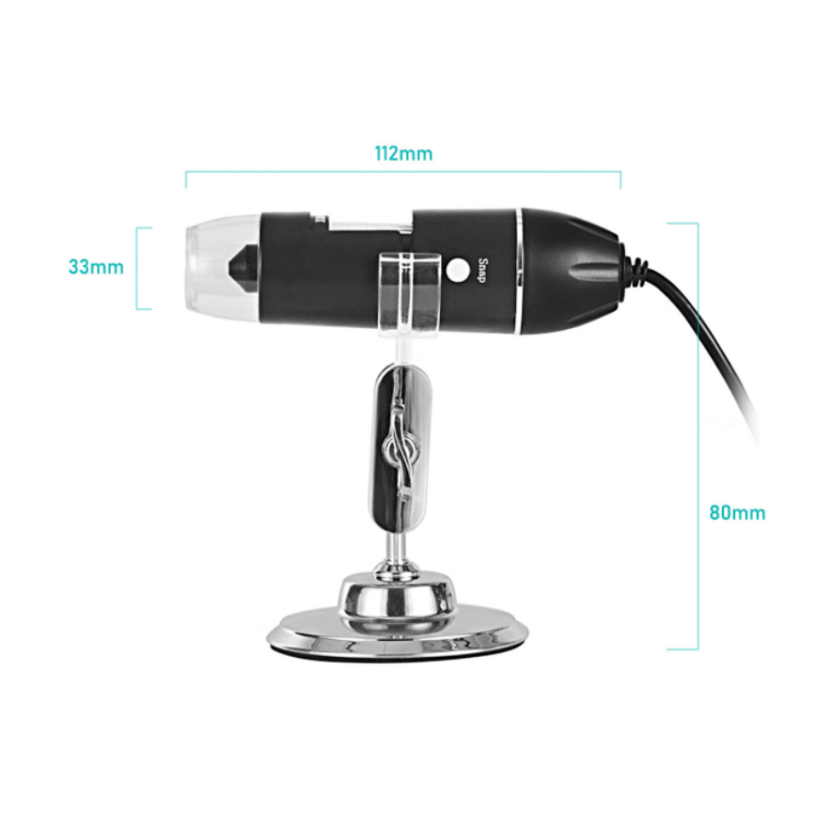

Features:
1. A good quality to use in Inspection dissection/examination, Plant dissection/examination, Skin examination,
2. Scal examination, Textile Inspection, Jewelry Inspection, Collections/Coin Inspection, Printing Inspection, PCB or PCBA Inspection and so on.
3. The microscope is made up of high-quality IC and electronic components, with clear image quality, low power consumption, high-resolution, applies to small objects to be larger
4. Photo and video production, is the best choice of small objects recognization

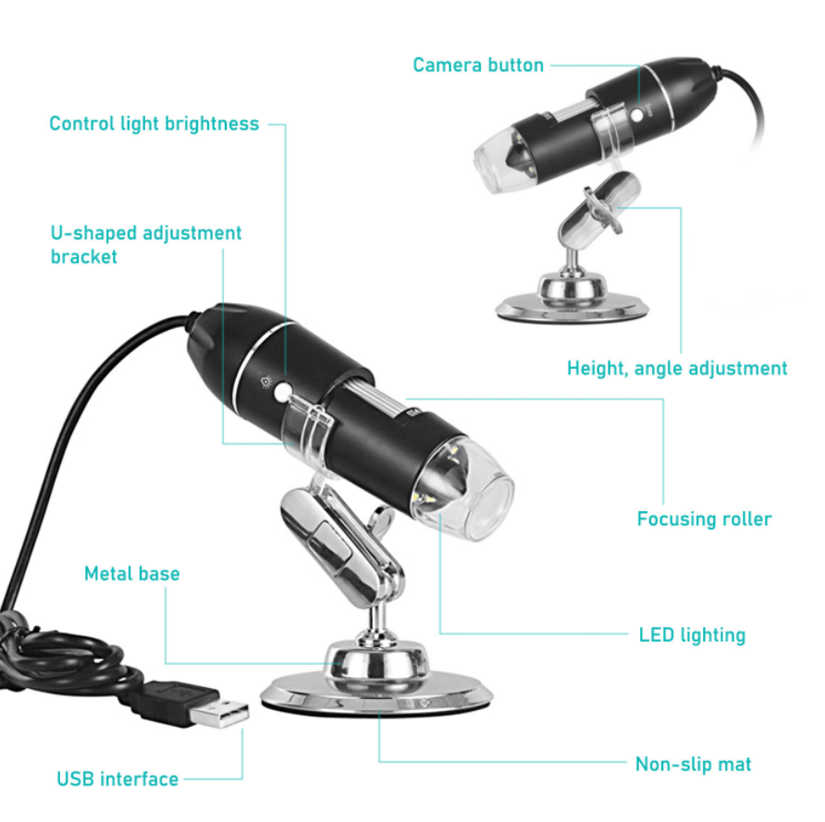

SPECIFICATIONS:
Chip: dedicated 16Bit DSP
Image Sensor:0.3M HD CMOS Sensor
Magnification: 0X-1000X
Photo/Video: Built-in
Auxiliary light source: 8 white LED lights
Image resolution: 640X480
Digital zoom: 5-stage
Imaging distance: manual adjustment 0~40mm
Fixed base: universal metal base
CD: Contains drive, measurement software, instructions
Support system: WINDOWS /VISTA
Power: USB (5V DC)
Computer interface: USB2.0
Dynamic Frames: 30f/s Under 600 LUX Brightness
Illumination range: 0-30000LUX line control adjustable
Body size: 112mm (length) 33mm (outer diameter)
Base effective height: 80mm, GW: 380g
Body color: matte black, other colors can be customized

